CBCT Dose Calculation: Accuracy Assessment of four Different Methods

A. Barateau (1,2), N. Perichon (3), C. Hervé(3), O. Henry (3), R. De Crevoisier (1,2,3), C. Lafond (1,2,3)

1 Inserm, U1099, 35000 Rennes, France

2 Université de Rennes-1, LTSI, 35000 Rennes, France

3 Centre Eugène Marquis, Rennes, France

***Introduction***

Cone Beam CT (CBCT) images aim at target volume repositioning before treatment fraction. These images may be used for dose calculation in order to dosimetrically quantify anatomical variations that occurs during treatment. The main limits are image quality, Hounsfield numbers (HU) consistency and CBCT reconstruction size. This study aims to assess accuracy of several CBCT dose calculation methods.

***Methods***

This study deals with four CBCT (XVI, Elekta) and CT image sets acquired on the same day in context of weekly dose planning of one H&N patient treated with VMAT technique. CT-CBCT sets were used to quantify CBCT dose calculation accuracy by investigating four methods: i) use of a density to HU relation from phantom CBCT image (phantom HU-D relation), ii) use of a density to HU relation from patient CBCT image (patient HU-D relation) iii) density override by three classes threshold (air, soft tissues, bone) et iv) elastic deformation (Admire, Elekta) between planning CT and CBCT image, by creating a pseudo-CT. After rigid registration, plan characteristics are projected on CBCT images (or pseudo-CT) with Pinnacle v.9.10 (Philips).

Dose distribution comparison between CT-based (reference) and CBCT-based calculation was performed by a gamma analysis in 2D and 3D (γ2D and γ3D, criteria: 2%/2 mm, 30% threshold). Then, dose differences were reported in terms of 95% target coverage, parotid glands mean dose (Dmean) and PRV spinal cord maximum dose (D2%).

**Results:**

On average, γ3D (percentage of points with gamma < 1) was 93.4% with patient HU-D relation, 96.6% with phantom HU-D relation, 97.4% with 3 classes threshold and 97.7% with the pseudo-CT. The difference in parotid glands Dmean could reach 5% while differences for spinal cord D2% and PTV coverage were less than 1.5%, whatever the method.

The gamma analysis showed location of discrepancy areas: near body contour, regarding shoulders and in presence of heterogeneities (figure 1). These differences can be explained by the poor image quality and the HU inconsistency of CBCT images in some areas. The method with pseudo-CT seems to be the best to pass over these issues because densities come from planning CT.

**Conclusion:**

The four evaluated methods show that dose differences can reach 5% for parotid glands and are lower than 2% for spinal cord and target volumes. The 3D gamma analysis results (2%/2mm) are higher than 95% for three among four methods. However, additional uncertainties have to be taken into consideration in case of CBCT image delineation and/or calculation on truncated images. This preliminary study shows CBCT dose calculation feasibility to quantify impact of patient anatomical variations during treatment and trigger a new plan based on CT if necessary. The future work is real delivered dose monitoring, based on CBCT image, in perspective of dose guided adaptive radiotherapy.

**Keywords**: Adaptive Radiotherapy ; Cone Beam CT (CBCT) ; Dose Calculation

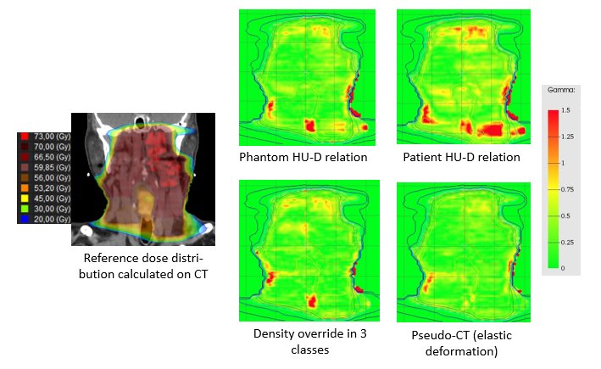

Figure 1: Dose distribution on CT image and 2D gamma analysis results in coronal plane for 4 CBCT dose calculation methods (example for one images set CT-CBCT).