**Title**: Comparison of algorithms AAA and Acuros (AxB) on heterogenous medium

**Autors**: C. Bouyer(1), M. Fargier-Voiron(1), A. Beneux(1)

(1) Service de Physique Médicale et Radioprotection, Centre Hospitalier Lyon Sud, Pierre-Bénite F-69495, France.

**Introduction:** A Boltzman equation based algorithm is now implemented on the Eclipse treatment planning system for calculating the dose distribution. Acuros performances are announced to be close to the Monte Carlo ones. However, implementing a new algorithm in routine is not without consequences, even if the dose calculation is more realistic.

The aim of this study is to compare the algorithms AxB (V13.6) and AAA (V13.6) with gafchromic films measures for simple situations (bone phantom and air cavity phantom).Then, the PTV coverage on patients will be compared between AAA and AxB algorithms.

**Materiel and methods:** First, dose calculations and measures were done on a bone phantom composed of a hollow bone with an air cavity, placed in a water tank, and on an air cavity phantom made of 2cm, 4cm and 8cm height of air surrounded by water equivalent RW3 plates. For this latter phantom, Acuros calculations were repeated assigning Hounsfield numbers to -1000 inside the air cavity. Squared fields irradiations were realized at fixed monitor units. For the bone phantom, a unique measure was done with a film perpendicular to the beam direction. For the air cavity phantom, measures were repeated with films perpendicular to the beam in 1 cm step. Calculated profiles and film measurements previously calibrated were overlaid.

Dose distribution of 3 patients treated on a vertebra and 4 patients for whom the PTV encompassed sinus, previously calculated with AAA algorithm, were compared with the dose calculated with Acuros algorithm. PTV coverage at 95% was reported and compared for both algorithms.

Results: Mean differences of 1.8% and 2.6% were observed on the bone phantom between Acuros algorithm and film, and between AAA algorithm and film, respectively. Concerning the air cavity phantom, differences between algorithms and films measurements increased when the cavity height increased, and were on average larger with the AAA algorithm : for 8 cm height: 26.8% vs 7.7%, for 4 cm height: 10.2% vs 5.8%, for 2 cm height: 2.0% vs 1.9%. Acuros calculations were closer to the film on the first cm but larger discrepancies appeared at the end of the air cavity (figure 1). This phenomenon was in part corrected by HU correction (mean of -958 before correction against -1000 after correction) but on the contrary a difference in dose for the first cm was involved (Figure 1).

Finally, for both localizations on patient treatment planning, a mean loss of about 2% in PTV coverage was found with the algorithm Acuros with doses holes phenomena in air and/or in bone. Without prescribed dose or coverage objectives adaptation, final dose calculation with Acuros would lead to an increase of the delivered dose.

**Conclusion:** Either in bone or in air cavity, decreases in PTV dose coverage for patients were in agreement with observations on phantoms. Moreover, it seems that the Acuros algorithm is extremely sensitive to a small HU variation. Further measurements are in progress to quantify the impact of HU variation on Acuros calculations, in particular due to artefacts on CT images.

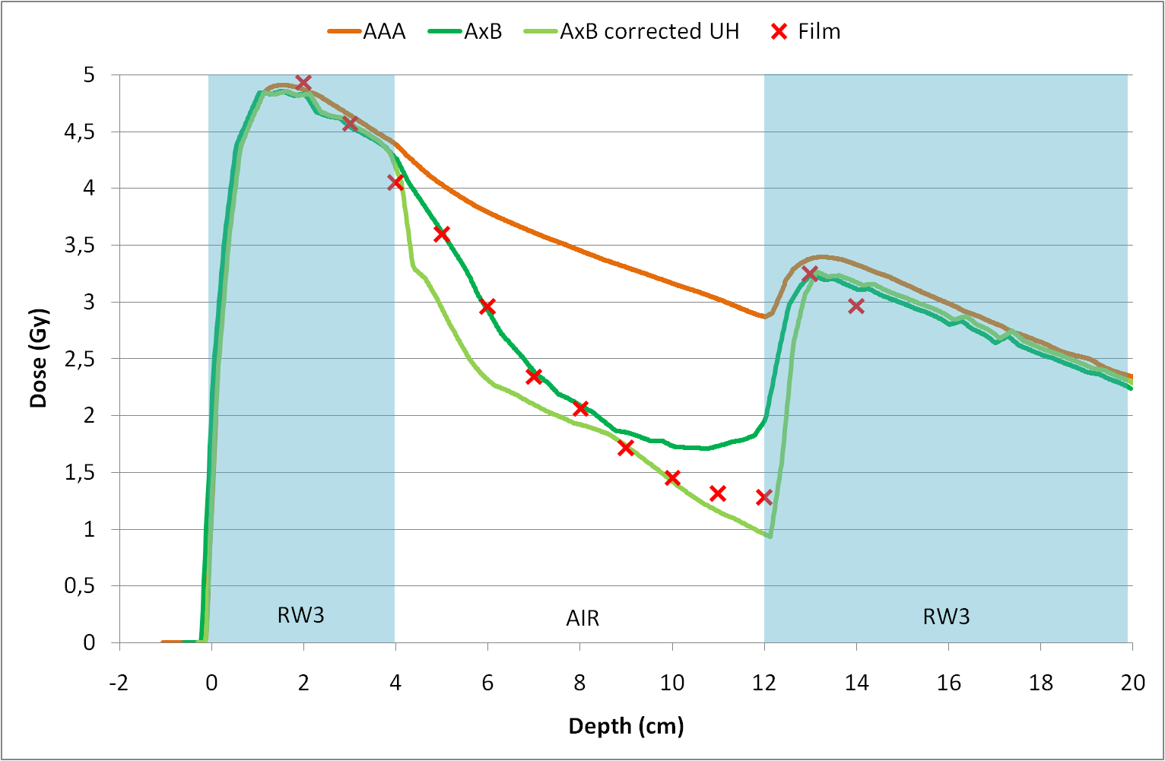

Figure 1: Evolution of the calculated dose with AAA and Acuros algorithms and measured with gafchromic films at different depths in the 8cm height air cavity phantom.