# *VMAT* and lung target: observation and quantification of interplay effect in stereotactic conditions

**I. Bessières, M. Gonod**Service de Radiophysique, Centre Georges François Leclerc, 21000 Dijon

**Introduction:** The precise dose deliverance in lung cancers is a high issue of the radiotherapy. Indeed, the mobility of the tumor due to the patient breathing complicates the success of the conformation and the correlation of absorbed dose to the tumor. This study focused on the dosimetric interplay effect which describes specific non-correlations between planned dose and the dose really delivered to the tumor. These differences are due to the combination of two movements: the MLC leaf modulation and the movement of the gross tumor volume in the internal tumor volume. The aim of this study is to highlight and to quantify de interplay effect by varying parameters related to the patient or the treatment in stereotactic conditions.

**Material and method:** The study has been realized on the CIRS 008A phantom (thorax model) containing a mobile lung cylinder with a spherical tumor insert (diameter of 1 cm). The planifications have been performed on Eclipse (v10, AAA) for a half arc (VMAT, 6 MV, Novalis Truebeam). The absorbed dose measurements have been done with a Pinpoint TM31006 ionization chamber centered on the tumor insert.

**Results:** The interplay effect has been measured considering three approaches: repeatability, modulation level and absorbed dose per fraction.   
The repeatability of a 2 Gy fraction has been investigated for 10 repetitions. We calculated a mean difference of 3% between the measured and the calculated dose with a standard deviation of 9% and a maximal value of 17%. This high level of disparity is due to the interplay effect. These orders of magnitude are those published in the literature [1,2]. We also observed a smoothing of the interplay effect at the scale of classical treatment.   
The modulation level has been studied by increasing the number of monitor units for a same prescription and a same configuration. Differences of 1,2%, 5,9% and 8,5% between the planification and the measurement have been calculated, respectively, for the first optimization plan, after 5% and 19% monitor units enhancement. This variation shows the correlation between the modulation level and the importance of the effect interplay.   
The impact of the absorbed dose per fraction has been investigated for fraction from 2 Gy up to 15 Gy. The relative differences between the measured and calculated absorbed dose are described in the following figure.

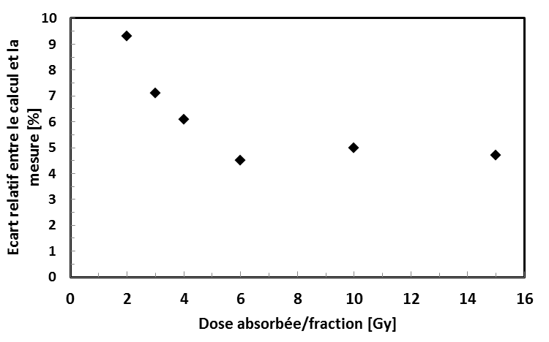

One can observe a decrease of the relative difference and consequently of the interplay effect with the raising of the absorbed dose per fraction. This result shows the smoothing of the interplay effect stereotactic dose per fraction.

**Conclusion:** This study has led to highlight and quantify the interplay effect, particularly by reproducing results from the literature. Bases of a coming work on the interplay effect quantification in stereotactic conditions have been defined. The final goal is to explore the whole patient, machine and dosimetric parameters in order to limit and reduce the interplay effect importance.

[1] Jiang *et al.*, 2003, An experimental investigation on intra-fractional organ motion effects in lung IMRT treatments, *Phys. Med. Biol.* Vol. 48, 1773—1784.  
[2] Ross *et al.*, 2006, Measurement of interplay effect in lung IMRT treatment using EDR2 films, *Am. Coll. Med. Phys.* Vol. 7